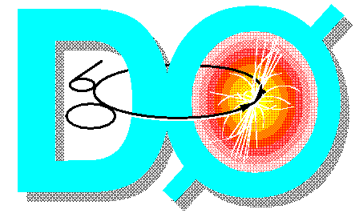
Current Status of the
DØ Experiment
Fermilab PAC Meeting
Status on October 19, 2001

Introduction
We present below a brief report on the status and near-term plans for the DØ experiment. The hardware status is summarized in Section 2, which begins with a discussion of the status of the detector sub-systems. We then devote the next two sub-sections to the Fiber Tracker readout and trigger hardware, followed by an update on the trigger systems. The Offline computing system is described in Section 3. We present in Section 4 a brief snapshot of our physics results, including J/ψ, W and Z production, and offer a short conclusion in Section 5.
In the interest of brevity, and to avoid redundancy, we direct the reader to the Run 2b Trigger Conceptual Design Report for a more detailed description of the DØ trigger system than we have been able to include here. This document has been distributed to the Committee under separate cover and can be found at: http://D0server1.fnal.gov/projects/run2b/Meetings/PAC/Nov01/PAC_web.htm.

Hardware Status

Detector Sub-Systems
The DØ silicon detector (SMT), which has about 800K channels, was fully cabled and powered by the end of May, 2001. At the beginning of the current October shutdown, approximately 85% of the sensors were timed in and routinely included in the commissioning and global data taking runs. The SMT cooling system runs at the nominal temperature of –10 degrees Celsius. Initial instabilities in the high voltage currents have been addressed. A significant amount of effort has gone into understanding the calibration and alignment of the detector and into developing the tracking software. Data from both special SMT-dedicated runs as well as general global runs are used for these studies.
The remaining ladders still exhibiting difficulties are being probed in detail at the detector face in the inter-cryostat gaps, as well as further downstream in the readout chain, as necessary, during this shutdown. Other work includes rework of a few power supplies, including fuse replacements and trip level adjustments. After the October shutdown, the high priority tasks will be the improvement of the silicon online monitoring, continuation of clustering and tracking studies, and further work on the detector alignment. Given the complexity of the SMT, the detector is performing exceptionally well.
The Fiber Tracker (CFT) and the Central and Forward Preshowers (CPS, FPS) are installed and fully cabled, with all clear fiber waveguide bundles having been installed, tested and connected to the VLPC cassettes either prior to (CFT, CPS), or shortly after (FPS), roll in. These three sub-detectors share the same readout system: VLPCs, Fiber Tracker Trigger (SIFT) chip for triggering, and SVXIIe for detector readout. All 99 VLPC cassettes have been assembled, tested and characterized, and installation into the two cryostats below the detector platform was completed in July. The cryogenic system for the VLPCs has been cycled a number of times – initial testing, power outages, during the staged cassette installation, etc. – and has performed very reliably and without incident. Installation of the production hardware for the Fiber Tracker front end readout and trigger systems is proceeding as scheduled during the October shutdown. A more complete discussion of this installation is provided in Section 2.2 below. To date, we have been commissioning a 4.5 degree φ sector of the Fiber Tracker using prototype Analog Front End (AFE) stereo boards. Much progress has been made aligning the detector, both with respect to the silicon and the Tevatron beam spot, quantifying the in-situ light output, exercising the reconstruction software, etc.
The DØ calorimeter precision readout is fully instrumented, commissioned and timed in to within 20ns. The fraction of channels that are either dead or excessively noisy is small (less than 0.5%). Fine tuning of the timing and repair work on the remaining channels is being pursued during the October shutdown. The liquid argon purity has been measured to be less than 0.7 ppm oxygen contamination equivalent. The calorimeter trigger was fully instrumented and used for the central region of the detector (|η| < 0.8) prior to the shutdown, and will be extended to the more forward region (|η| < 1.6) during the shutdown. Data has been taken with the Level 1 and Level 3 calorimeter triggers; commissioning of the Level 2 calorimeter trigger will begin soon after the shutdown. Initial verification of the energy scale using the Z⁰ resonance gives the expected response to within 10%. The Inter-Cryostat Detector (ICD), a scintillator-based detector which samples energy lost by jets traversing the barrel and end calorimeter cryostat walls, was partially instrumented prior to the October shutdown, allowing for initial commissioning during the early portion of the run. We expect to have the ICD fully instrumented after the present shutdown.
The hardware for both the Central and Forward Muon systems was fully commissioned prior to the shutdown. This includes gas for the proportional and mini-drift tubes, high voltage, and front end electronics. The timing of both the tracking and trigger detectors were relatively adjusted and properly synched to the Tevatron beam cycle. The Level 1 muon trigger, using preliminary trigger tables, has been commissioned, and has been providing single and di-muon triggers throughout the full detector acceptance (|η|<2.0). The Level 2 and 3 triggers will be used after the current shutdown. Calibration procedures have been established, and extensive muon survey and alignment jobs have been completed. Minor improvements and modifications to the detectors and electronics are being planned for the October shutdown, including a purge of the gas systems and high voltage system recalibration. The current Muon Fanout Cards, part of the front end system, display intermittent problems that require manual intervention via crate rebooting. While these problems are infrequent and do not pose prohibitive problems for data taking at the current rates, we have decided to redesign and rebuild the 25 cards needed ( 18 for system, 7 for spares + test setups). This process is well underway, and we expect the full complement of cards to be ready for installation and commissioning by February, 2002.

Installation of Fiber Tracker Readout & Trigger Hardware
Installation of the Analog Front End (AFE), mixer, and digital readout boards will complete the DØ Central Fiber Tracker (CFT), Central Preshower (CPS) and Forward Preshower (FPS) subsystems. DØ needs 214 AFE cards to read out the tracking systems. Each AFE card accommodates 512 VLPC channels with analog and discriminated readout. Over 100 digital cards are required to calculate Level 1 triggers from the CFT axial fibers and the FPS strips and to prepare and transmit the CFT and FPS trigger data to the Level 2 trigger.
The AFE cards have been ordered in three lots. The first lot of 146 cards has been received. About 50% of the second lot of 54 cards has also been received and the remainder is expected by October 22. These first two lots complete the CFT. Production of the final lot of 44 cards (required for the FPS) will begin October 22 and is expected to finish in two weeks.
The AFE testing procedure requires five phases. The first four phases ensure that the cards have basic functionality. All but a few of the 146 cards of the first lot have been tested. Of these about 100 cards pass and the remainder require some repair. The fifth phase of the testing examines the performance by characterizing the number of dead channels, pedestal means and widths, discriminator outputs, and transmission. Ninety-seven boards have gone through this final phase. Of these 46 have been cleared for installation. Generally a board is considered acceptable if less than 5 channels malfunction. None of the cards from the second or third lots have been tested yet.
Since the current shutdown began, a total of 28 AFE cards have been installed in three of 13 crates. The preliminary performance of these cards has been satisfactory: one or two failed and the remainder had one or two bad channels. In summary about 70% of the cards have been delivered, 25% are candidates for installation, and 15% have been installed. The key issues pertaining to complete installation of the AFE are delivery of the third lot and repair of those cards failing the tests. Priority is being given to completing the central trackers first.
The CFT/CPS digital system includes 20 Mixer cards, which convert cylindrical organization of the axial CFT fibers into azimuthal trigger towers, 45 trigger cards that find tracks and electrons, and 29 broadcasters and collectors that transmit the axial and stereo data to Level 1 and Level 2. The FPS digital system has 16 trigger cards and 5 broadcasters and collectors.
All of the Level 1 CFT cards (mixer, trigger, collectors, and broadcasters) are on hand and most of them are certified for installation. About 30% of the system is installed (trigger, collectors, and broadcasters) and installation of the balance will occur the week of October 22. About 50% of the Level 2 CFT/CPS cards are on hand and the balance will be delivered in 6 weeks. All of the Level 1 and Level 2 FPS cards are at Fermilab but require handwork and testing before installation; these should be available in one month. In summary about 80% of the cards have been delivered and about 20% of the system installed. Priority has been given to the Level 1 CFT/CPS system.

Trigger Systems
We include for reference in Figure 1 below a block diagram of the DØ Level 1 and Level 2 trigger systems. A diagram of the currently implemented Level 3/DAQ system is provided in Section 2.3.3 below.

Level 1 Trigger
The Level 1 trigger system is providing hardware-level muon and calorimeter triggers since approximately April and July, respectively. These are the basic triggers used for data collection. Readout of the Level 1 calorimeter information to Level 2 and beyond is needed for further event discrimination. The firmware to complete this readout is currently being finalized, and is expected by mid-November, matched in time to the availability of the Level 2α system for commissioning. The hardware required for creation of a Level 1 Fiber Tracker trigger (CTT) – Analog Front End boards (AFEs), Digital Front End boards (DFEs), mixer hardware, and other elements – are all in hand, going through production tests, and are being installed during the October shutdown. We expect the CTT trigger to be fully instrumented by the end of the shutdown.
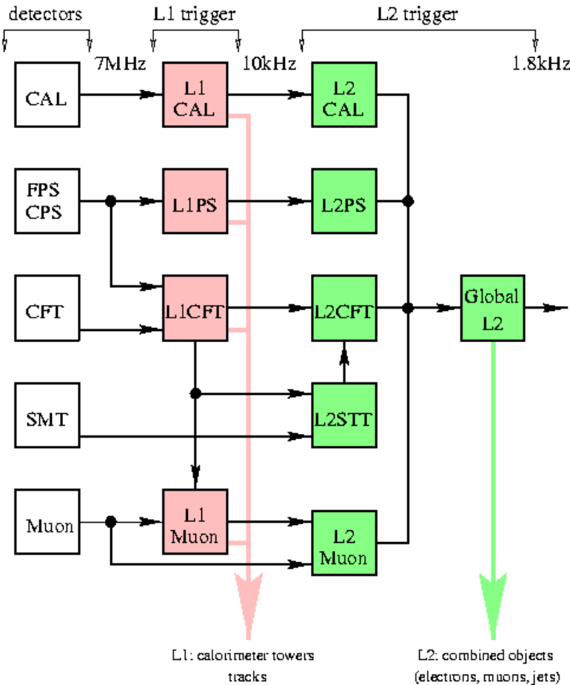
Figure 1: Block diagram of Level 1 and Level 2 triggers, indicating the individual trigger processors that comprise each level.

Level 2 Trigger
Our baseline system for the Level 2 trigger for Run 2a is based on DEC Alpha processors, developed in collaboration with CDF. Due to the considerable difficulties associated with the initial production run of the Level 2α processor boards, however, we have pursued an additional path that utilizes β processors (Level 2β). The status of each is described in turn below.
We have recently received the full order of 11 α-boards from the latest production run. Tests of the first few have yielded encouraging results. We currently have a total of 11 working α boards: of these, 7 are from this latest production run, with the remaining 4 having been culled from previous production or pre-production runs. We expect to be able to certify a total of 15 working boards when we finish the testing and debugging of those remaining from the latest production run. The focus of the Level 2a commissioning effort is on single α-crate preprocessor systems. We expect to have a Level 2 system - consisting of Level 2 Global, Level 2 Muon and Level 2 Calorimeter - ready for commissioning and running in mark-and-pass mode by December. During this phase, we will begin the online study and tuning of the Level 2 algorithms. Integration of the Fiber Tracker and Preshower triggers will occur soon thereafter. We expect to be using the Level 2 for rejection online by March, 2002.
The Level 2β processors will be implemented using a modular approach, taking full advantage of industry-standard components and requiring both hardware and software compatibility between α and β processors. This facilitates more seamless integration into the experiment. The Level 2β project is well under way, and consists of a fruitful collaboration between Orsay, University of Virginia, and University of Maryland. Orsay is providing engineering resources to build the 9u boards and develop the system firmware. Virginia is specifying the processor, writing software, and, in conjunction with Maryland, specifying firmware functionality. Changeover from the α system to a fully β-based Level 2 trigger is expected to occur in the fall of 2002.

DAQ/Level 3 Trigger
With an input event rate of 1000 Hz and an accept rate of about 50 Hz, the DØ data acquisition and Level 3 filtering system will support the full Run 2 physics program. (At the nominal event size of 250 Kbytes, the input and output bandwidth are 250 Mbytes/sec and 12.5 Mbytes/sec, respectively).
Figure 3 shows the current implementation of the L3 data acquisition and filtering system, which supports commissioning at a peak rate of 80 Hz and a steady state rate of ~30Hz. Event data is collected from the front-end crates with a system of custom-built hardware and transmitted to a filtering farm of 48 Linux nodes. The VME Buffer Drivers (VBDs) are legacy hardware from Run 1 and are installed and functioning. Three prototype VBD Interface Boards (VBDIs) and VBD Readout Controllers (VRCs) transmit data via ethernet to software emulated Segment Bridges (SBs) and Event Tag Generators (ETGs). The VRC is a PC 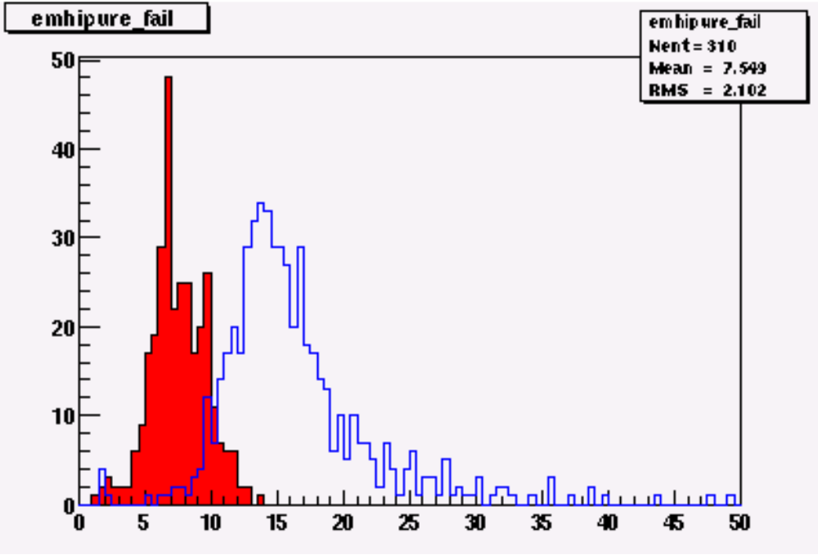with a custom optical link card called the Serial Interface Board (SIB). Event rejection is achieved in the farm by partial reconstruction and filtering of each event. Presently, the events arrive and are filtered in ten or so Level 3 nodes.
We have been applying filters at Level 3 to electromagnetic objects triggered at Level 1. The results are shown in Figure 2. The Level 3 EM filter is definitely aiding our event selection, with a rejection level of about 3.

Figure 2: E_{T} distribution of the electromagnetic objects sent from Level 1 for those passing the Level 3 filter (blue, or empty, histogram) and the ones (prescaled) failing it (red, or filled, histogram).

By the end of the calendar year, we anticipate that numerous upgrades and additions will result in an expanded Level 3 capacity of 500 Hz and improved filtering capability. The installation of production VBDIs and VRCs will have occurred by this time. Similarly, the emulated Segment Bridges (SBs) will be upgraded and increased in number. These upgrades are scheduled for October and November. The ethernet switch between the L3 nodes and filter farm, as well as the 48 filtering nodes, are on hand and installed. We expect to have the filtering farm fully commissioned by mid-November.
The system described above represents the initial implementation of the baseline data acquisition system for DØ. Due to schedule and technical difficulties associated with this project, however, DØ is aggressively developing a backup solution based upon commercial networking hardware. Preliminary analyses and tests show that such a system is feasible and can provide a bandwidth of 1 kHz. The system is composed of single-board computers (SBC) in each front-end crate, which communicate with the filtering farm through a series of ethernet switches. The SBCs transmit data to a series of 4 Cisco 2948G switches, which, in turn, transmit data to a single Cisco 6509 switch. The large switch finally routes the data to Level 3 filtering nodes.
SBCs and switches have been ordered for a “slice” test in early November. Both the Fermilab Computing Division and DØ are participating in these tests and the system design. The full slice has ten SBCs to read out at least one VME crate of each type. A Cisco 2948G switch transfers the data from the 10 SBCs on 100 Mbit copper cables to 1 Gbit optical fibers and a Cisco 6509 switch transfers the data from there to the Level 3 nodes, and the 48 Level 3 filter nodes.

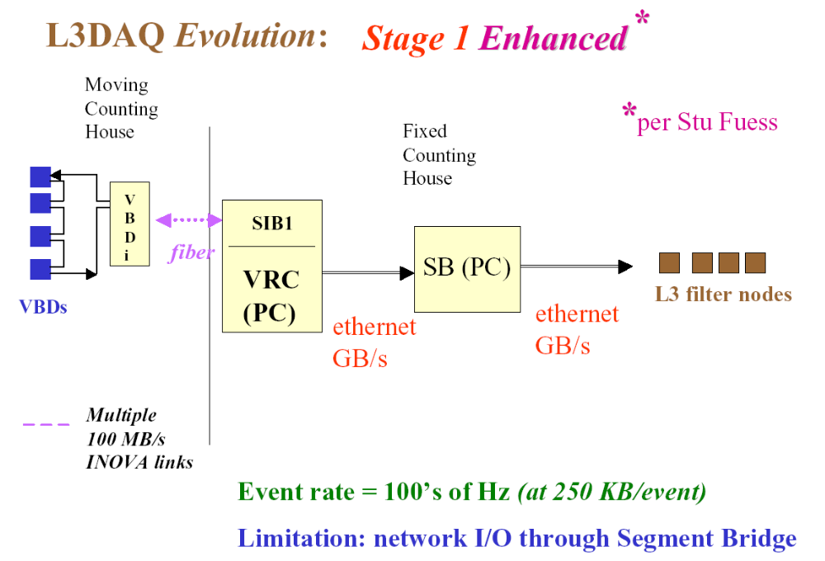
Figure 3: Current data acquisition scheme implemented at DØ.

Offline Computing

Data collected by the online system are shipped to the Feynman Computing Center via fast optical links. The SAM data handling system, jointly developed by DØ and the Computing Division, tracks, stores, and accesses the data files at each level: raw data, reconstructed data, and summary data (in the form of root-tuples). It also handles simulation data, which are produced for DØ at several collaborating institutions in the U.S. and Europe, and stored over the network into the robots in FCC using SAM. The data handling system is a fully distributed one that gives the experiment great flexibility in moving data sets around and deploying its resources effectively.
Offline reconstruction takes place in the offline Linux farm, whose processing power is currently well matched to the average DAQ rate. Within FY02, we will upgrade the farm to match the designed DAQ rate. Processing of the global data set was completed within a few days of the start of the shutdown, and we are now beginning a complete reprocessing of the data set with the newest version of the reconstruction program. The reconstruction and simulation groups release stable verified versions with major functionality increases on a regular schedule, every three months. We can make corrective releases to these stable versions, with bug fixes and well-contained functionality increases, as often as once a week. (This is in addition to the weekly development releases.) The current version of the reconstruction meets the Run II specifications for CPU and memory usage, and its functionality is illustrated in the physics results section, below.
Most of the Run II computing hardware is in place and commissioned, and performing up to specifications. The exception is the Exabyte Mammoth 2 tape drives, which have performed very poorly. We have been able to significantly mitigate the impact of these failures by using the ENSTORE system, developed by the CD, which dynamically allocates drives. We were able, using SAM, to quickly deploy direct data logging to the large disk set on our central SGI Origin machine when the tape drives began to fail massively near the end of the data taking run. We plan to switch during the shutdown to writing to STK tape drives in a different robot. The STK drives performed superbly in a 30 TB test, and the switch should be relatively easy, because the SAM/ENSTORE system hides such details from the users.

Physics Results
The integrated luminosity as measured at DØ since early August is shown in Figure 4. The delivered luminosity, shown by the upper curve, is that provided by the accelerator to the experiment. The middle curve, labeled “exposed”, represents the amount of integrated luminosity that the experiment has been used for special runs, commissioning, or global data taking. The lower curve denotes the integrated luminosity used for global data taking, in which the entire experiment was made available for read out for either commissioning or physics data taking.
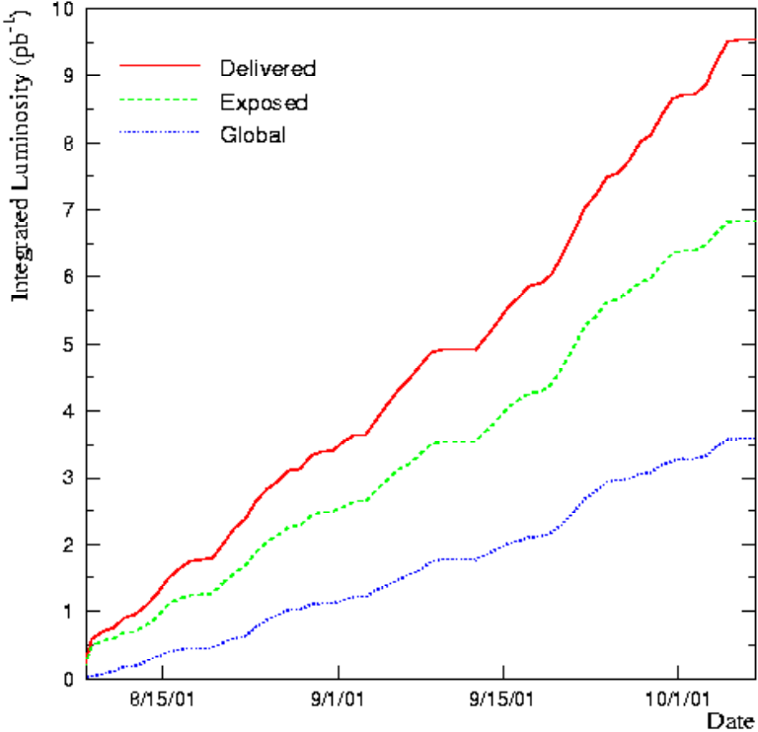
Figure 4: Integrated luminosity as measured at DØ since early August. Details are provided in text.

Over the past few months a lot of effort has gone into alignment and calibration of the detector. In particular the silicon and partially instrumented fiber tracker detector have been used to exercise our tracking algorithms. We have measured the transverse position of the interaction point with an accuracy of about 300μm and established that the detector was not exactly centered on the beamline, but offset by 5 mm in the vertical and 4 mm in the horizontal plane. Based on this information the detector has already been moved by this amount during the current shutdown. We have also checked the alignment between SMT and the partially instrumented CFT and verified that it is correct to within 40μm.
We have recorded about 1.8M events, processed about 1M events, taken during global runs, and in the following we show the results we have obtained from this data set. Some of the most striking events at a hadron collider are due to W,Z production. In Figure 5 we show an event display with two views of a W boson decaying to an electron and the corresponding neutrino. The signature for the neutrino is missing transverse energy.

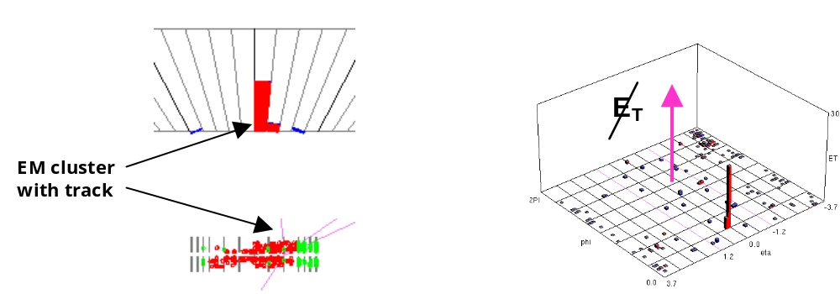
Figure 5: Event displays for a W boson decaying to an electron and a neutrino, showing the side (left) and lego (right) detector views.

In analyzing about 1 day worth of data (~0.1pb⁻¹) with the latest version of the reconstruction program, we see a transverse momentum distribution for electromagnetic objects that is consistent with expectation from W bosons and some fakes (see left hand plot in Figure 6). Requiring two isolated electromagnetic objects with E_{T} > 20 GeV and imposing shower shape cuts, we reconstruct an invariant mass distribution as shown in the right hand plot of Figure 6. Although the absolute energy calibration of the calorimeters is not performed yet, we see a clear indication of Z production, with the Z decaying to two electrons.
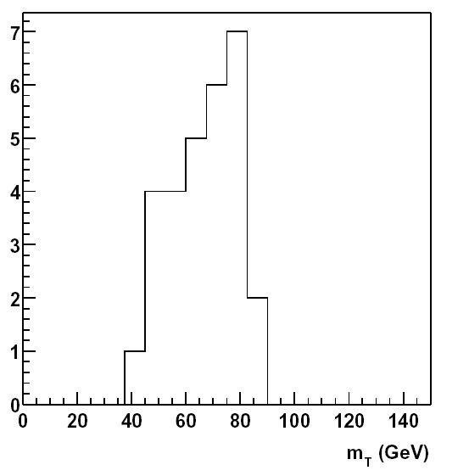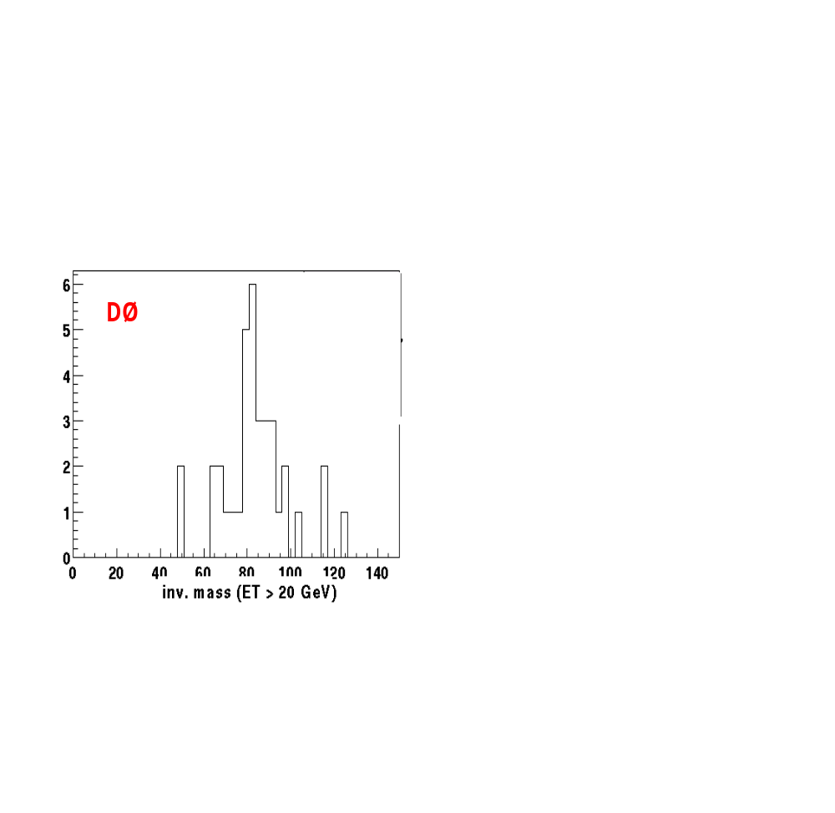
Figure 6: Distribution of Transverse Mass of W bosons candidates decaying to electrons plus neutrinos(left). Invariant mass distribution for candidate Z bosons decaying to electrons (right).

In Figure 7 we show a calorimeter energy lego plot of a W+2jet event, with the W decaying to electron plus neutrino. The raw transverse energy for the jets are 17 and 13 GeV.

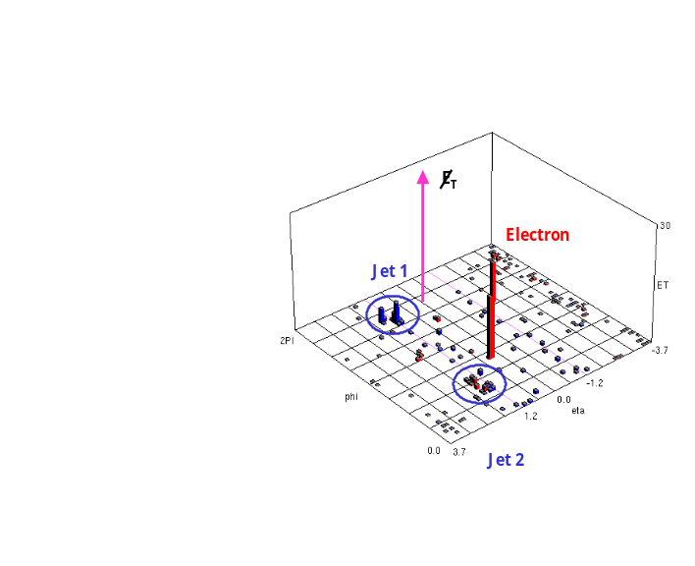

Figure 7: Lego plot for a W boson + 2 jet candidate event. The uncorrected transverse energy of the jets are 13 and 17 GeV.

Until the fiber tracker will be available, it will be difficult to enrich the W,Z samples where the bosons decay to muons. However, one of our first such candidate events is shown in the event display in Figure 8. We have analyzed data collected with the muon system in the forward region. Constructing the invariant mass for dimuon events, we see a clear J/ψ signal, to be used later as a calibration tool (see Figure 8).

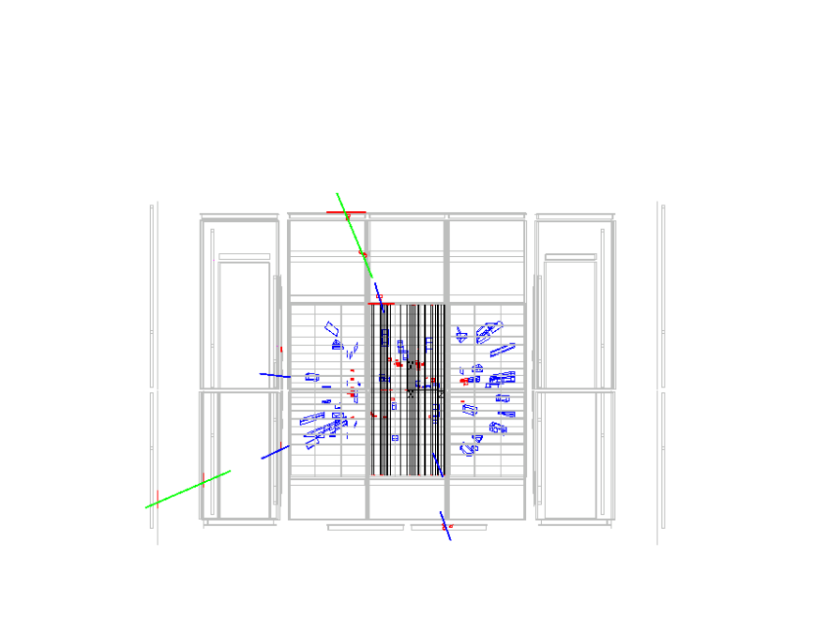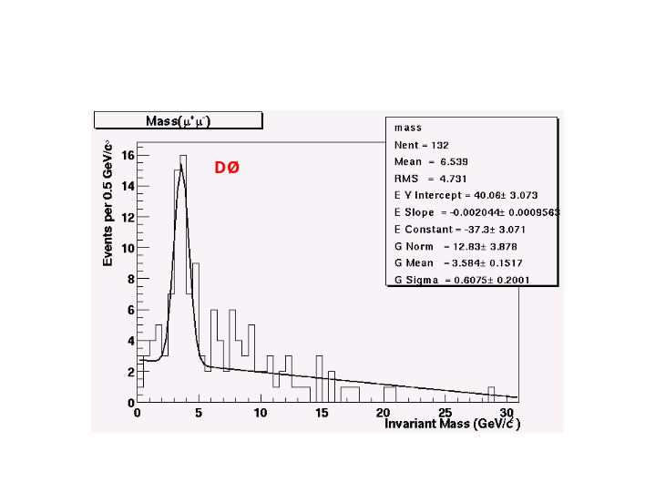

Figure 8: Event display for a candidate Z boson decaying to dimuons (left). J/ peak extracted from forward dimuon decays (right).

Conclusions
Since rolling the DØ Detector into the Collision Hall in March, 2001 for the start of Run 2, the collaboration has made tremendous progress in commissioning and integrating the experiment, and beginning the pursuit of the Run 2 physics program. All detector systems – Silicon, Fiber Tracker, Central and Forward Preshowers, Calorimeters and Muon - are installed and cabled. With the exception of the CFT, for which the readout is being installed during the October shutdown, the front ends of all systems are installed and at various stages of commissioning and data taking. The offline computing system is being exercised as designed, and is being fully integrated into the overall commissioning and data-taking program. The trigger system is adequate for detector commissioning and accumulation of initial physics data, but there is work remaining in order to realize the fully functioning Run 2 rate capability. We believe, however, that most major technical hurdles have been addressed, and have every expectation that a system capable of handling the rates required for physics-quality data taking will be available early in 2002.

